Jahnin Smith

STAT 200 Midterm Exam
20 Questions (5 points each)
Instructions: Show your work! Round all decimals to the hundredths place. If numbers are small, then round to 4 decimal places. If no work or calculator steps are shown, no credit will be given for correct answers. Include units and proper notation as needed to get full credit for answers (ex: P(x) for probability, μ for population mean, and σ for population standard deviation). If you are typing in Word, you can find these symbols in the Insert tab under Symbols. Remember appropriate titles and labels for graphs.
Submit your midterm as a single PDF file. Sign and date at the bottom of the exam.
1.1.2
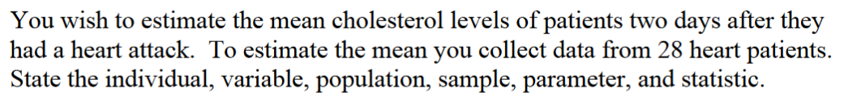

Individual – Patients with heart attack.
Variable – cholesterol level of patients.
Population – set of all heart attack patients with cholesterol levels two days after they had a heart attack.
Sample – set of all 28 heart patients.
Parameter – the mean cholesterol levels of all heart patients.
Statistic – the mean cholesterol level of all 28 heart patients.

1.1.10
State the measurement scale for each.
- Temperature in degrees Celsius
(answer) The degrees Celsius measurement scale is the interval scale.

- Ice cream flavors available

(answer) We use the nominal scale to state the ice cream flavors available.

- Pain levels on a scale from 1 to 10, 10 being the worst pain ever

(answer) We use the ordinal scale to show the pain levels.

- Salary of employees

(answer) We use the ratio scale to measure the salary of employees.

1.2.6
Consider making a numbered or bulleted list of steps.
- First you need to define your population of study.
- Then divide you sample into clusters.
- Select clusters to use as your samples randomly.
- Collect data from the sample clusters.
1.4.3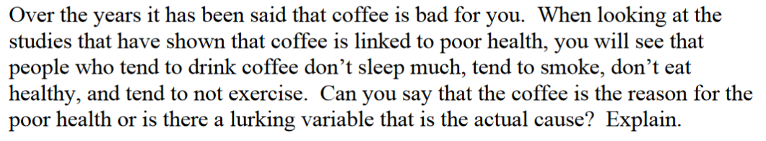
(answer) There is a lurking variable that is the cause of poor health. Lurking variables are the linking variables that if combined with a given explanatory variable they would result in the response variable occurring but they are not considered as explanatory variables.
2.1.1
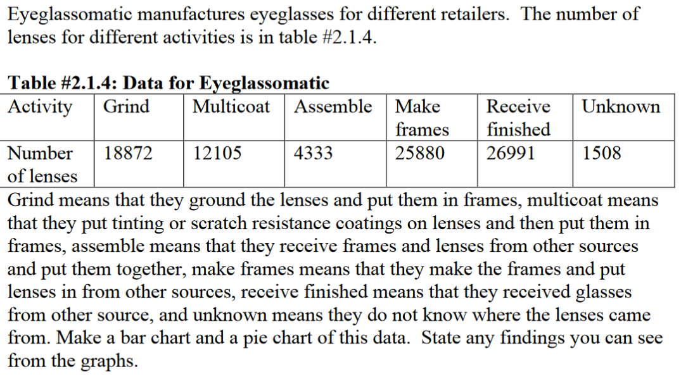

2.1.7
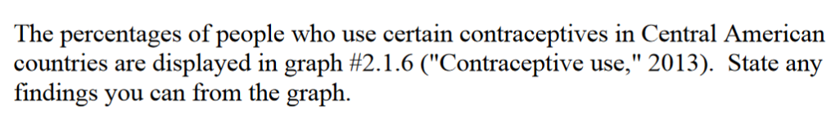
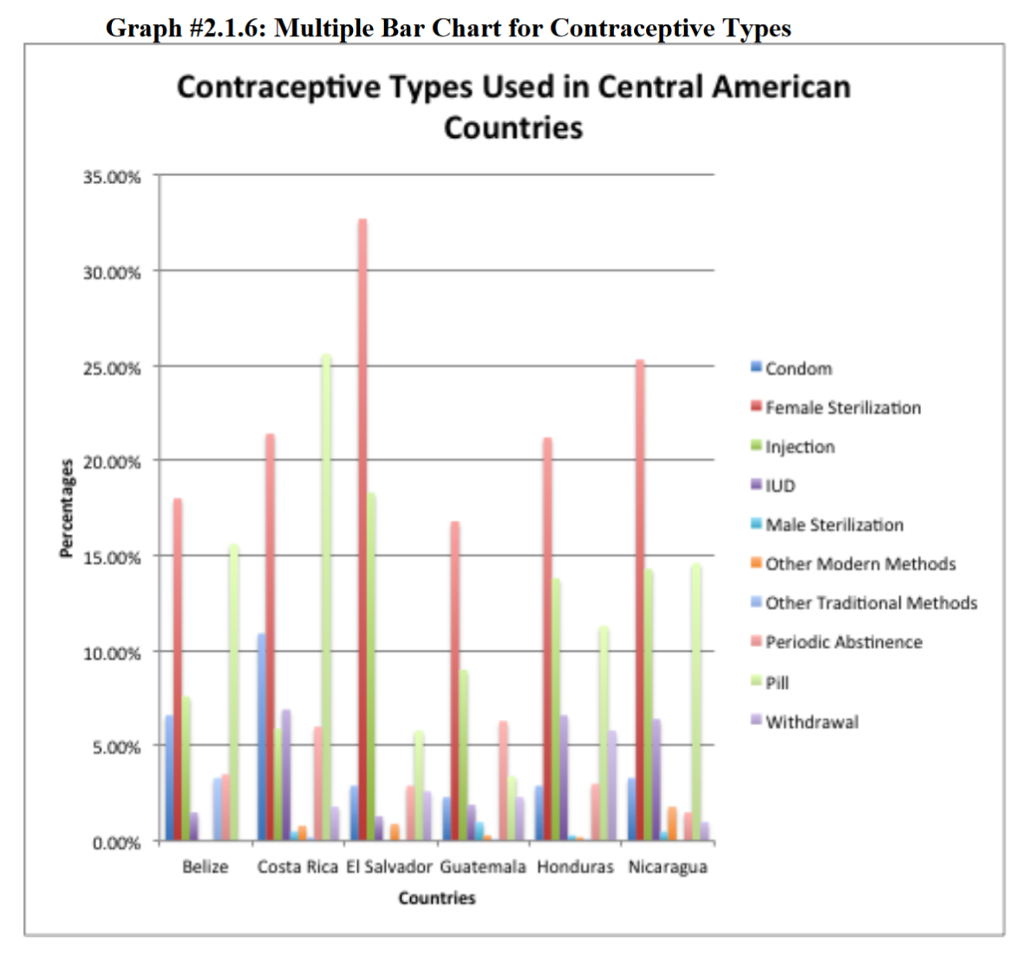

- In El Salador the female sterilization is the highest than the other states at 30% followed by Nicaragua at 25%.Male sterilization ia below 5% in all the states.
- The use of pills in CostaRica has the highest number of use at 25%
- Periodic absteinance is among the least methods of birth control used all the states majoring below 5%.
- Use of condoms is at 10% at its highest in these states.
- Use of injection being slightly above 15% in these states being El Savador which is the highest
- Traditional methods in all states as a method of birth control ,other modern methods ,withdrawal and IUD are all below 5% across all the states

2.2.4
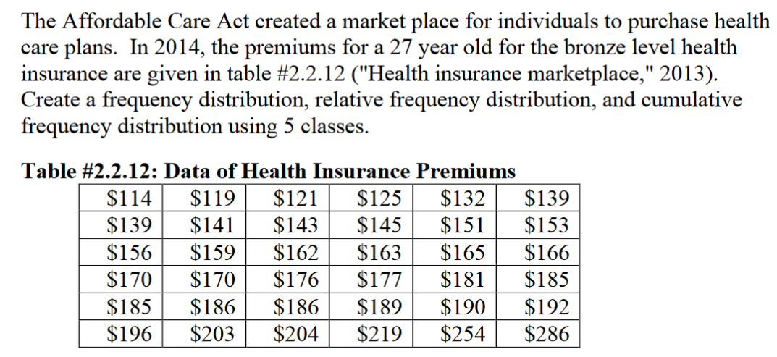

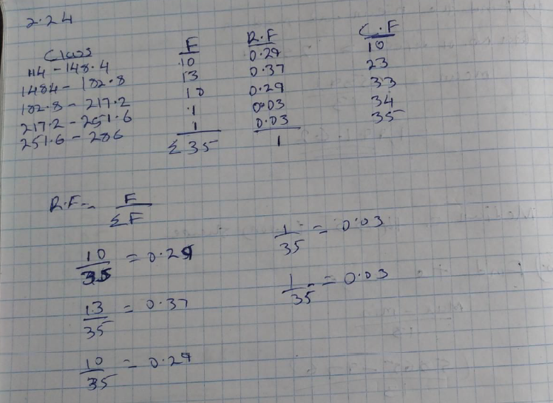

2.3.5
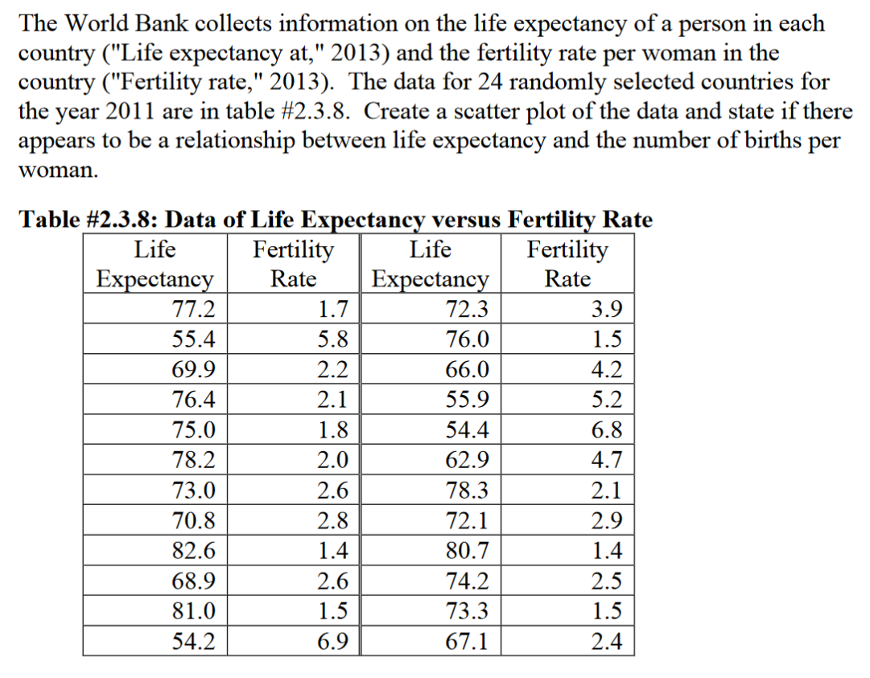

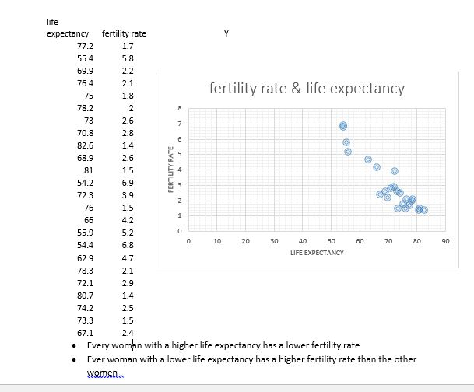
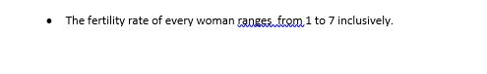

3.1.13
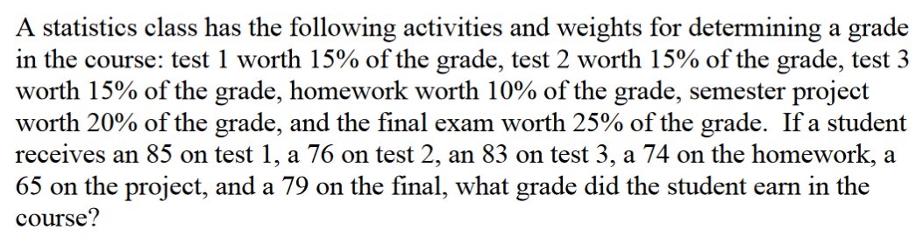

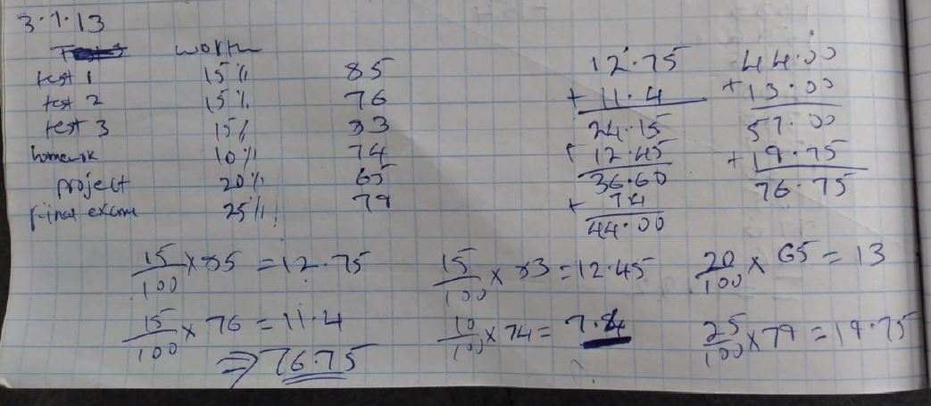

3.2.4
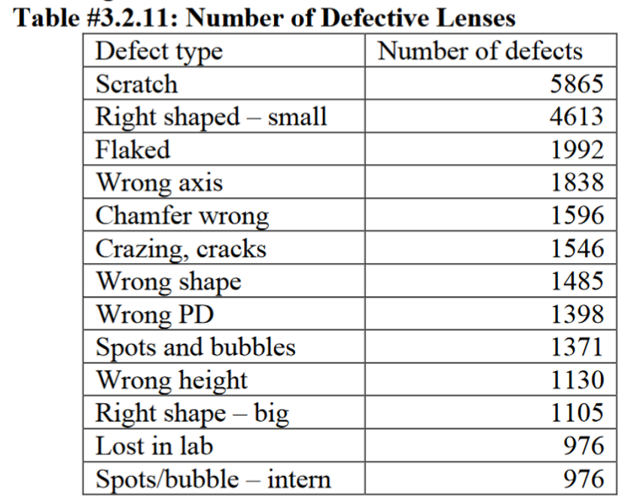
- Find the mean and median.
- Find the range.
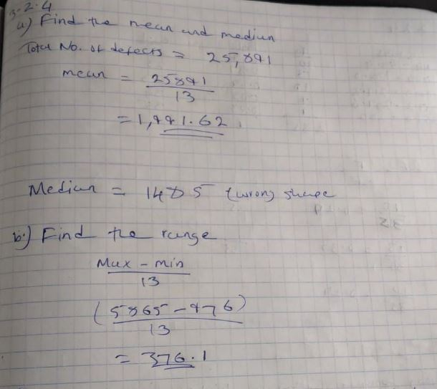
- Find the variance and standard deviation.

4.2.1
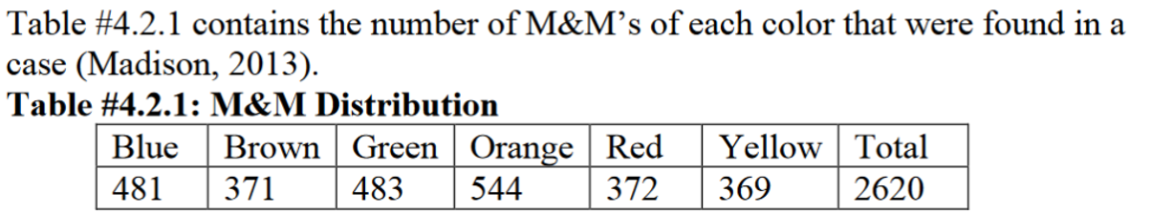
- Find the probability of choosing a green or red M&M.
- Find the probability of choosing a blue, red, or yellow M&M.
- Find the probability of not choosing a brown M&M.

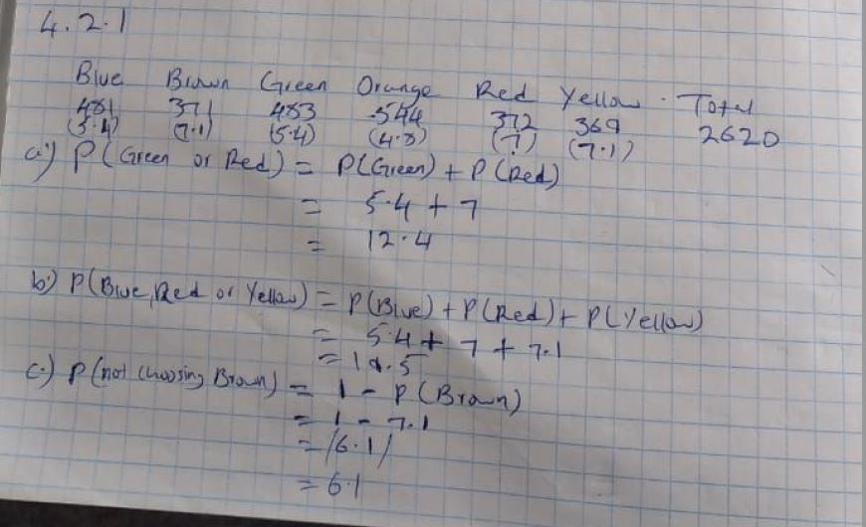
- Find the probability of not choosing a green M&M.

4.3.10
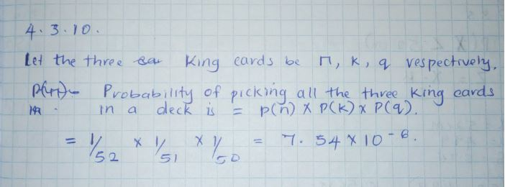

5.1.1
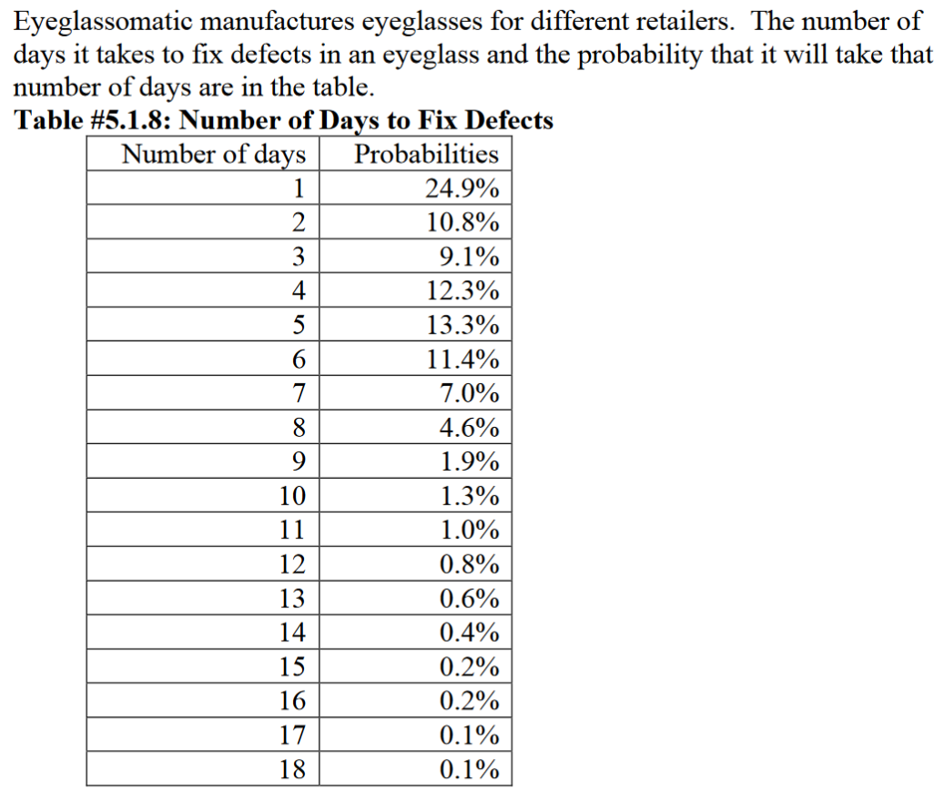
- State the random variable.
X - eyeglasses

- Draw a histogram of the number of days to fix defects.

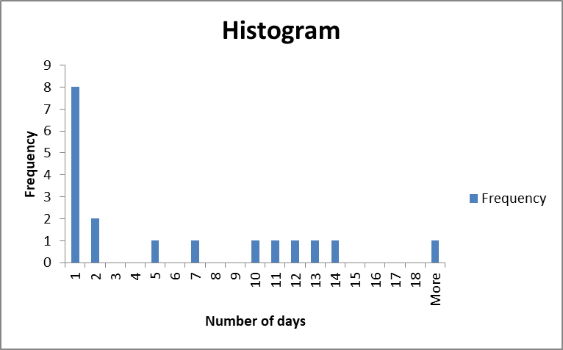

- Find the mean number of days to fix defects.
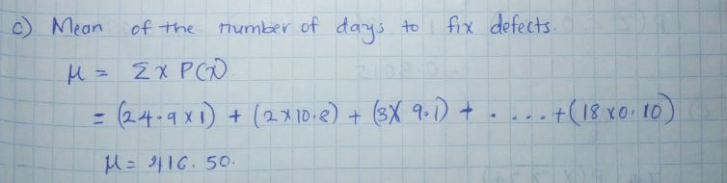

- Find the variance for the number of day to fix defects.

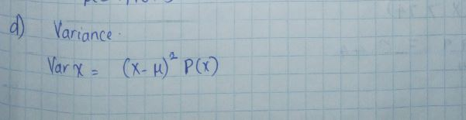

- Find the standard deviation for the number of days to fix defects.
- Find the probability that a lens will take at least 16 days to make a fix the defect.
- Is it unusual for a lens to take 16 days to fix a defect?
- If it does take 16 days for eyeglasses to be repaired, what would you think?

5.2.6
- P(x = 21)
- P(x = 6)
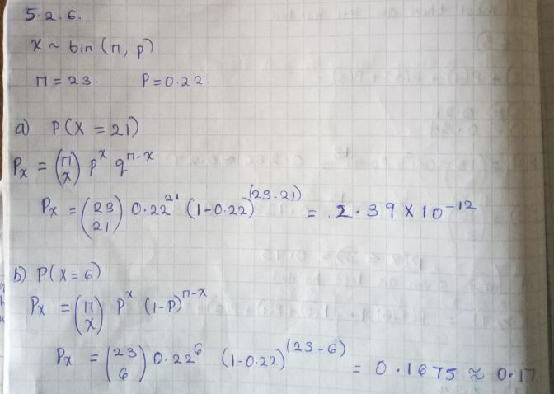

- P(x = 12)
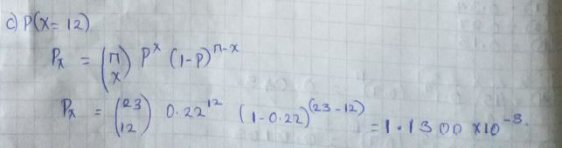

- P(x ≤ 14)

- P(x ≥ 17)

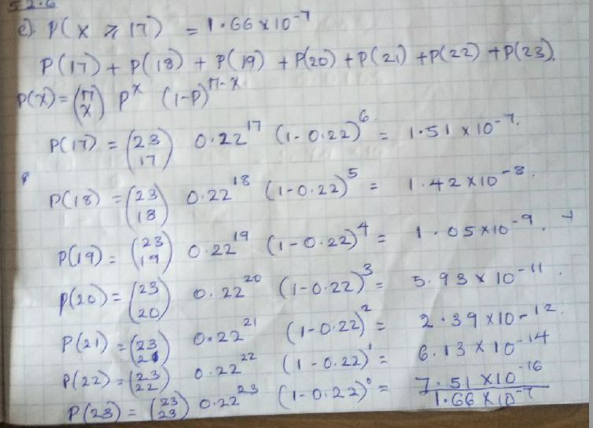
- P(x ≤ 9)

5.2.7
- State the random variable.
X = people who are left handed.
- Argue that this is a binomial experiment.
Binomial distribution is the probability of a success or failure in an experiment that is carried out multiple times. Now we have a group of 15 people and we need to check how many in the 15 people are left handed. The experiment will be carried out till we find the first success.
Find the probability that
- None are left-handed.

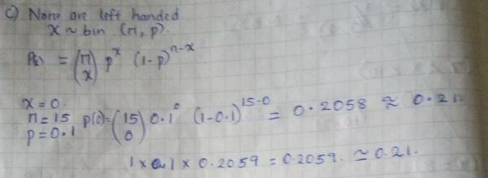
- Seven are left-handed.
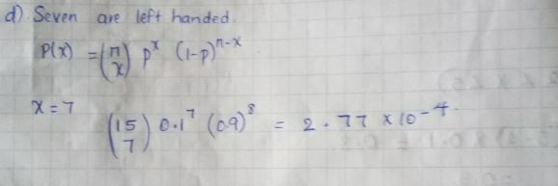
- At least two are left-handed.
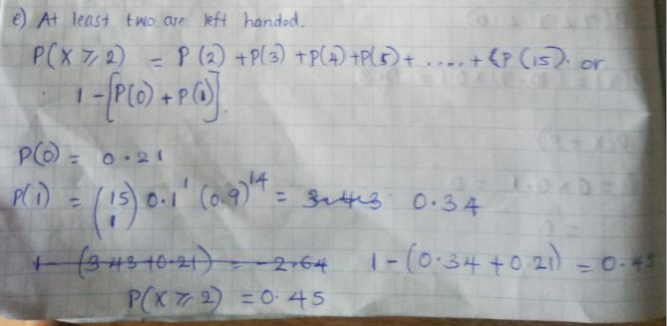
- At most three are left-handed.
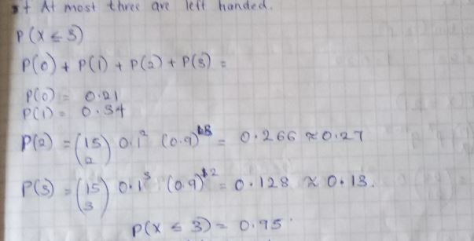
- At least seven are left-handed.
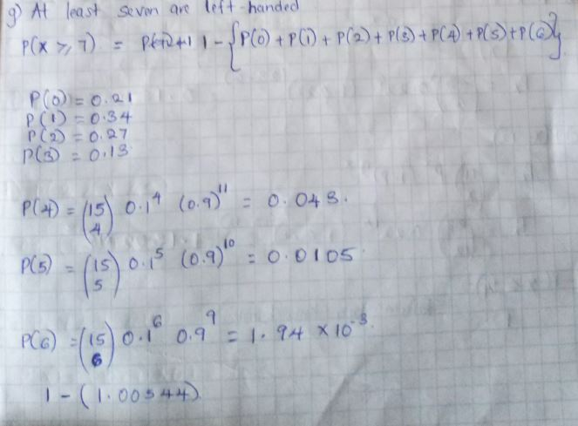
- Seven of the last 15 US Presidents are left-handed. Is this unusual? What does that tell you?

5.3.5
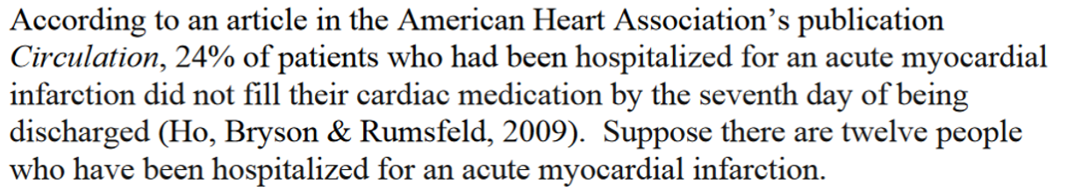
- State the random variable.
X- Acute myocardial infarction patients.

- Write the probability distribution.
The probability distribution is normal distribution. (see below)

- Draw a histogram (see Below)
x P(X= x)
0 4.00E-02
1 1.40E-01
2 2.40E-01
3 2.60E-01
4 1.80E-01
5 9.00E-02
6 3.00E-02
7 9.20E-03
8 1.80E-03
9 2.60E-04
10 2.40E-05
11 1.40E-06
12 3.70E-08
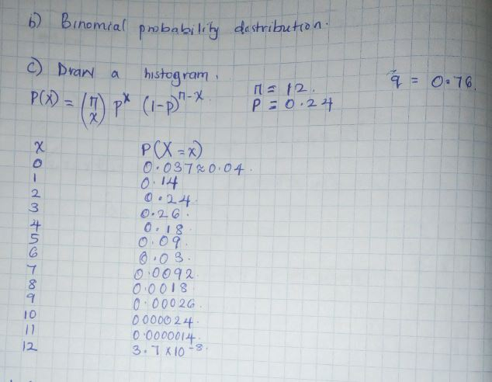

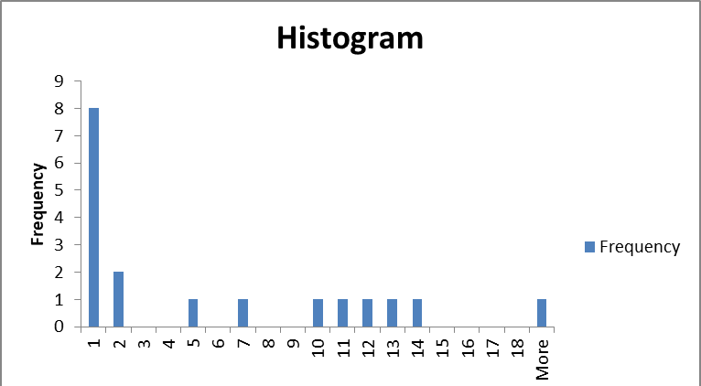

- Describe the shape of the histogram.
- Find the mean. (see Below)
- Find the variance. (see Below)
- Find the standard deviation. (see Below)

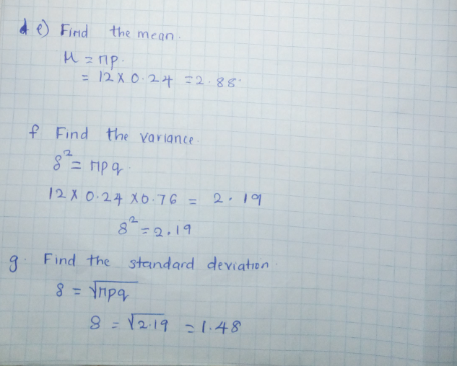

6.1.1
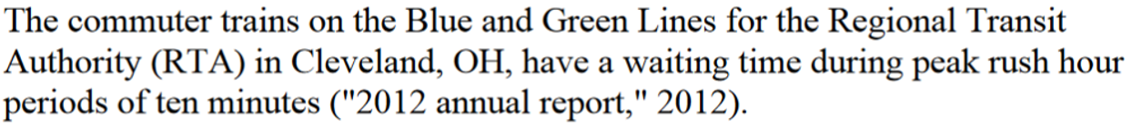
- State the random variable.
X - The waiting time during the peak hours.

- Find the probability of waiting between two and five minutes. (see below)
- Find the probability of waiting between seven and ten minutes.( see below
- Find the probability of waiting eight minutes exactly. (see Below)

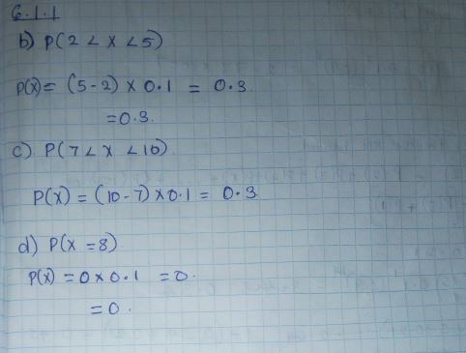

6.3.5
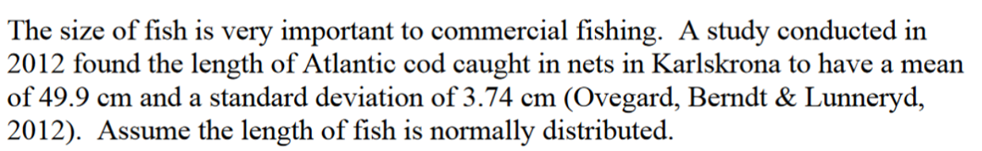
- State the random variable.
X – Size of the fish.

- Find the probability that an Atlantic cod has a length less than 52 cm.

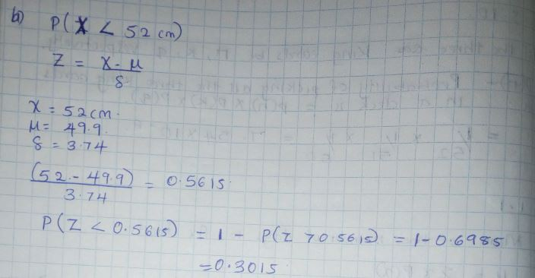
- Find the probability that an Atlantic cod has a length of more than 74 cm.
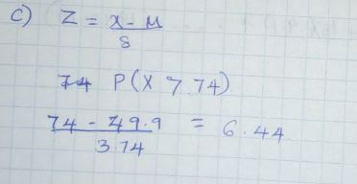
- Find the probability that an Atlantic cod has a length between 40.5 and 57.5 cm.
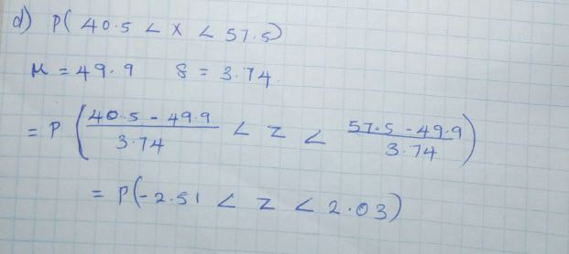
- If you found an Atlantic cod to have a length of more than 74 cm, what could you conclude?

- That the maximum length a fish grows is more than 74.

- What length are 15% of all Atlantic cod longer than?

6.4.1
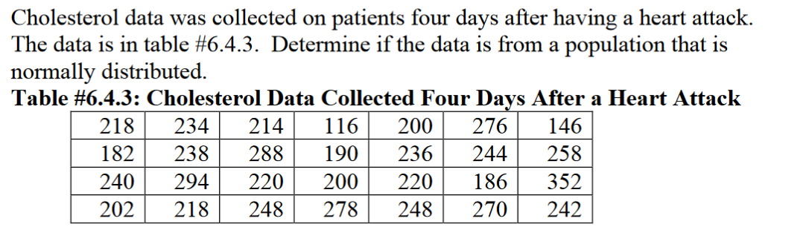

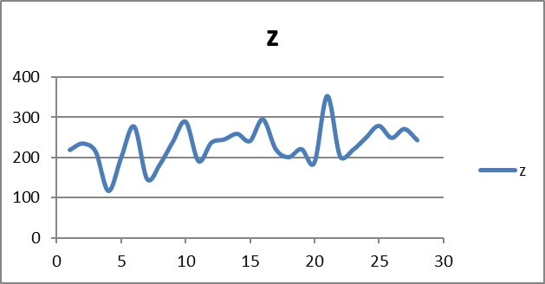

(answer) The data is not normally distributed. It has so many outliers.

6.5.3
i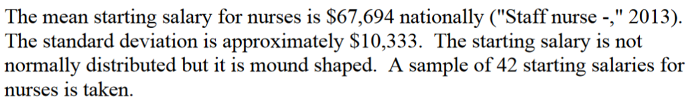
- State the random variable
X- Starting salary for nurses.

- What is the mean of the sample mean?
- What is the standard deviation of the sample mean?

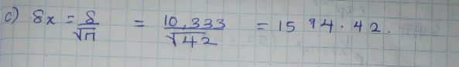
- What is the shape of the sampling distribution of the sample mean? Why?

- The shape is a mound shape. The population is mound shaped hence is the sample.

- Find the probability that the sample mean is more than $75,000.
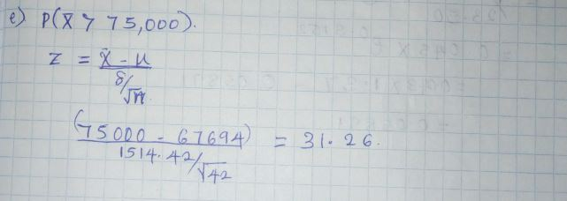
- Find the probability that the sample mean is less than $60,000.
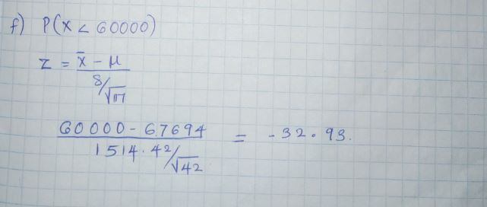
- If you did find a sample mean of more than $75,000 would you find that unusual? What could you conclude?

- I would conclude that the maximum starting salary a nurse can get is above $75,000.

I have completed this exam myself, working independently and not consulting anyone except the instructor. I have neither given nor received help on this exam. Leaving the information below blank will result in a grade of zero for your midterm exam.

Name:____________________________________ Date: ________________________

Signature: ________________________________

